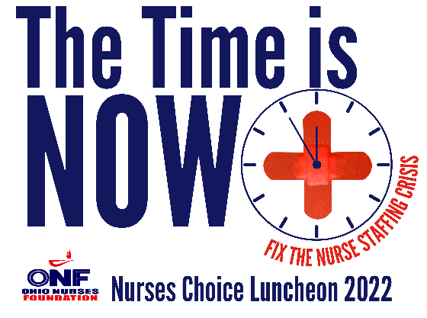
2022 SPONSORSHIP INFORMATION
PLATINUM-$1,500
- Sponsorship presenter
- Verbal recognition during event
- Individual slide during live event highlighting the sponsor
- Prominent postings within the ONF’s social media platforms: hyperlinked logo
(almost 30,000 followers)
- Hyperlinked logo prominently displayed on the ONF website
- ½ page ad in Ohio Nurses Review (10k circulation)
- Listing within Ohio Nurse (200k circulation) and Ohio Nurses Review
GOLD-$750
• Verbal recognition during event
• A blended slide during live event highlighting all GOLD sponsors
• Postings within the ONF’s social media platforms: hyperlinked logo
(almost 30,000 followers)
• Hyperlinked sponsor logo displayed on the ONF website
• Listing within Ohio Nurses Review
I LOVE NURSES-$250
- A blended slide during live event highlighting all I LOVE NURSES sponsors
- Verbal recognition during event (may request to op-out of name being announced)
- Listing within Ohio Nurses Review

For more information contact Michelle at mdonovan@ohnurses.org
Register your support at www.ohionursesfoundation.org

